**WIRELESS USING UDP**

**AIM**

To create a wireless topological network simulation using UDP in ns2

**ALGORITHM:**

1.START

2.Initialize Necessary variables for Wireless Connection.

3.Create Tracing and Animation Files.

4.Set Temporary and Load the values of the Variables.

5.Create nodes and mark their Location.

6.Create Channel (i.e) Communication Path for the nodes.

7.Specify mobility codes if anu of the nodes are moving.

8.Set CBR Traffic.

9.Run the Simulator.

10.STOP

**SOURCE CODE**

set val(channel) Channel/WirelessChannel;

set val(prop) Propagation/TwoRayGround;

set val(netinterfacetype) Phy/WirelessPhy;

set val(mac) Mac/802_11;

set val(interfacequeue) Queue/DropTail/PriQueue;

set val(linklayer) LL;

set val(antenna) Antenna/OmniAntenna;

set val(maxpac) 50;

set val(nodenum) 6; #Total number of mobile nodes

set val(routingp) AODV; #Adhoc Ondemand Distance Vector

set val(x) 500;

set val(y) 500;

set ns [new Simulator]

# nam file creation

set tracefile [open output.nam w]

$ns namtrace-all-wireless $tracefile $val(x) $val(y)

#topography creation

set top [new Topography]

$top load_flatgrid $val(x) $val(y)

create-god $val(nodenum)

set c1 [new $val(channel)]

#set c2 [new $val(channel)]

$ns node-config -adhocRouting $val(routingp) \

-llType $val(linklayer) \

-macType $val(mac) \

-ifqType $val(interfacequeue) \

-ifqLen $val(maxpac) \

-antType $val(antenna) \

-propType $val(prop) \

-phyType $val(netinterfacetype) \

-topoInstance $top \

-agentTrace ON \

-macTrace ON \

-routerTrace ON \

-movementTrace ON \

-channel $c1

set n0 [$ns node]

set n1 [$ns node]

set n2 [$ns node]

#$ns node-config -channel $c2

set n3 [$ns node]

set n4 [$ns node]

set n5 [$ns node]

$n0 random-motion 0

$n1 random-motion 0

$n2 random-motion 0

$n3 random-motion 0

$n4 random-motion 0

$n5 random-motion 0

$ns initial_node_pos $n0 20

$ns initial_node_pos $n1 20

$ns initial_node_pos $n2 30

$ns initial_node_pos $n3 40

$ns initial_node_pos $n4 20

$ns initial_node_pos $n5 50

$n0 set X_ 10.0

$n0 set Y_ 20.0

$n0 set Z_ 0.0

$n1 set X_ 210.0

$n1 set Y_ 230.0

$n1 set Z_ 0.0

$n2 set X_ 100.0

$n2 set Y_ 200.0

$n2 set Z_ 0.0

$n3 set X_ 150.0

$n3 set Y_ 230.0

$n3 set Z_ 0.0

$n4 set X_ 430.0

$n4 set Y_ 320.0

$n4 set Z_ 0.0

$n5 set X_ 270.0

$n5 set Y_ 120.0

$n5 set Z_ 0.0

$ns at 1.0 "$n1 setdest 490.0 340.0 25.0"

$ns at 1.0 "$n4 setdest 300.0 130.0 5.0"

$ns at 1.0 "$n5 setdest 190.0 440.0 15.0"

$ns at 20.0 "$n5 setdest 100.0 200.0 30.0"

set udp [new Agent/UDP]

set null [new Agent/Null]

$ns attach-agent $n1 $udp

$ns attach-agent $n4 $null

$ns connect $udp $null

set cbr [new Application/Traffic/CBR]

$cbr attach-agent $udp

$ns at 0.1 "$cbr start"

$ns at 4.5 "$cbr stop"

$ns at 5.0 "finish"

proc finish {} {

global ns tracefile

$ns flush-trace

close $tracefile

exec nam output.nam &

exit 0

}

$ns run

**OUTPUT**

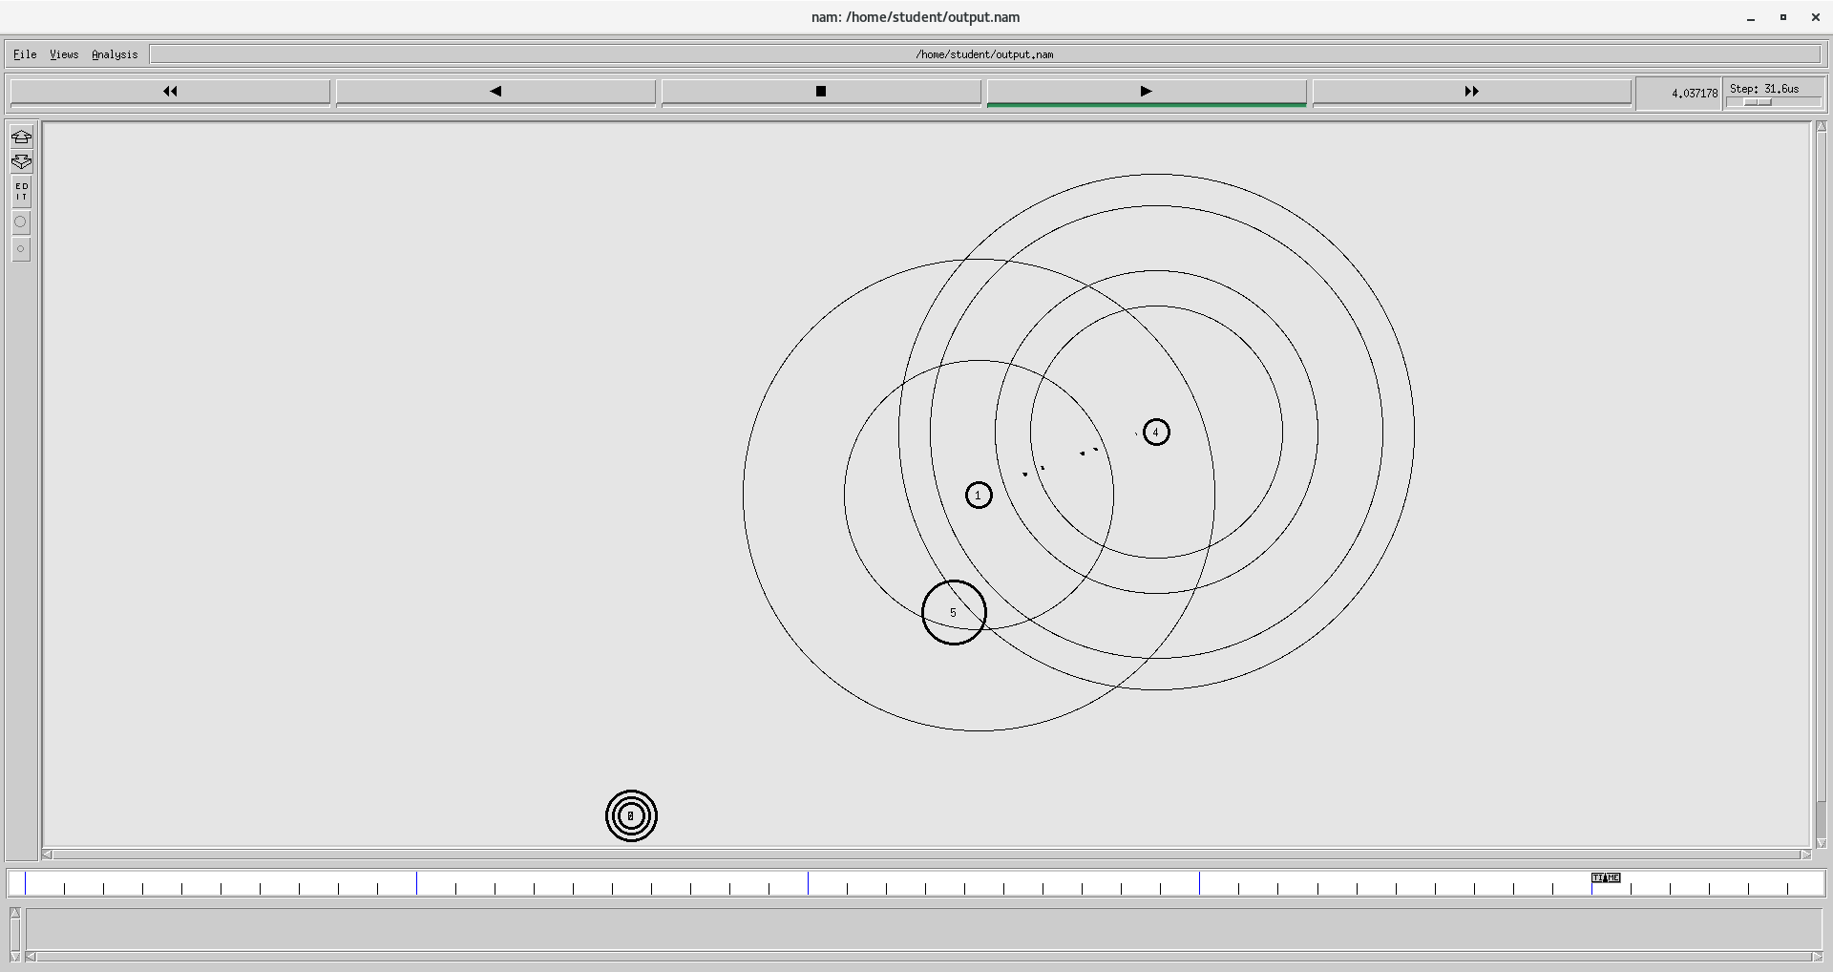

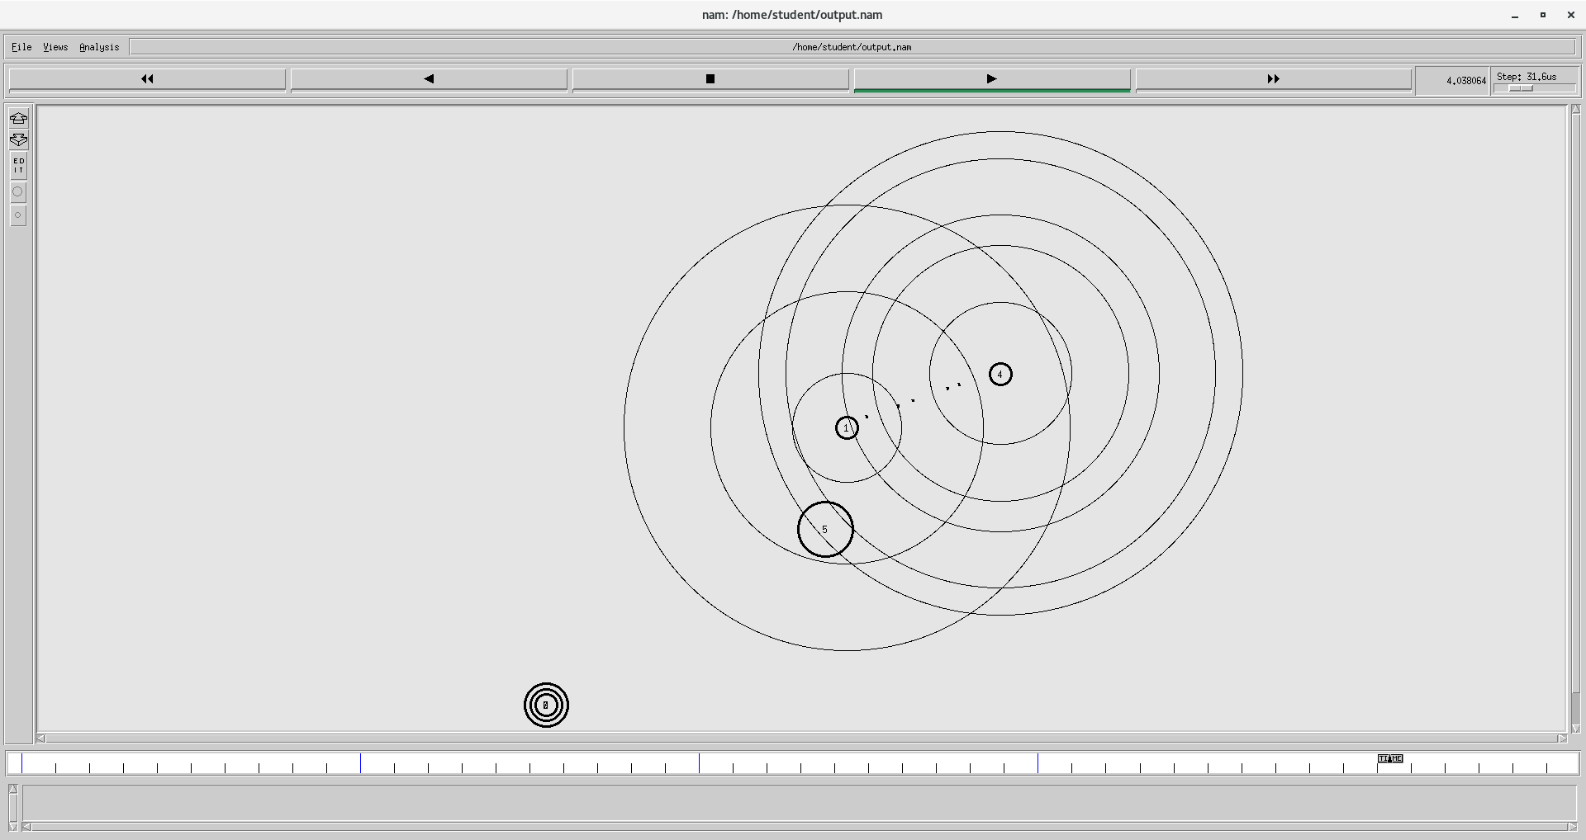

**RESULT**

Hence wireless network is simulated using UDP in ns2